Program Salt & Smooth

Statslibrary2

Laiba S Khan

2023

Table of Contents

Plot, Salt, Smooth 2

The Function 2

Program Plotter 2

Salter 5

Smoother 6

Maven 6

Matlab Octave 6

RSI Calculator 11

Normal Distribution, Gamma, Beta Distribution Essay 12

Formula Sheet 12

# Plot, Salt, Smooth

## The Function

The function that was chosen for this assignment was . This equation was chosen due to the way the graph appears, and its higher challenge to implement. The function includes both the eulers number, an exponent, and sin(x).

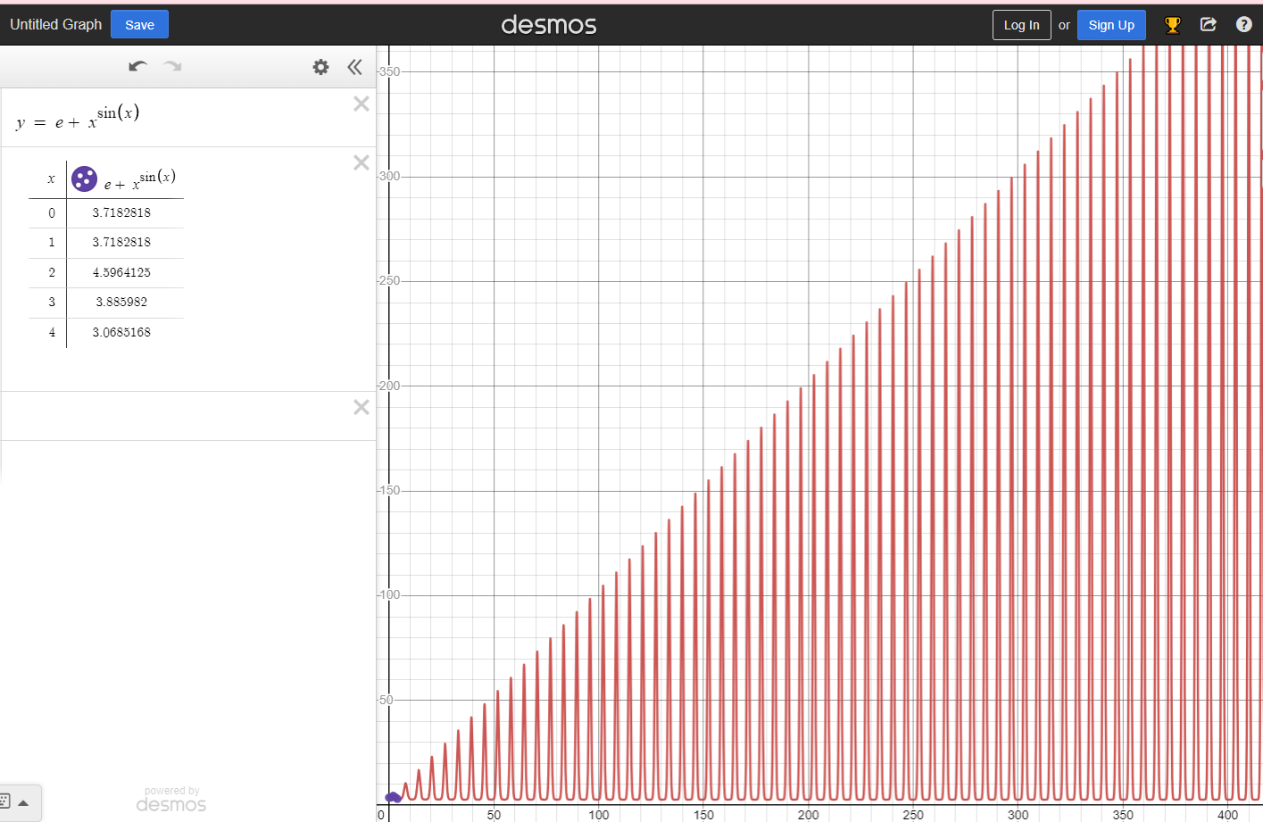

## Program Plotter

# ProgramPlotter.java was implemented with two methods, one for writing results into a CSV file, and one that calculated the function results. The method ResultsinRange method is as shown below.

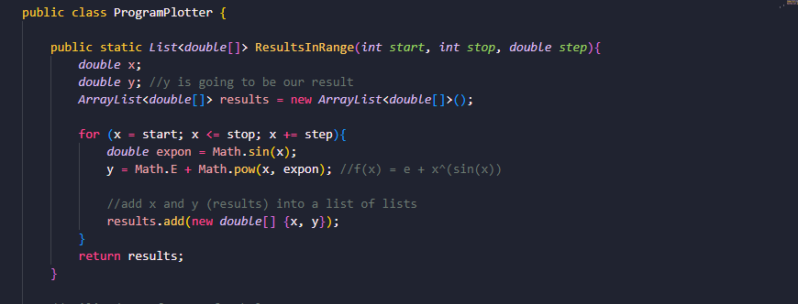

The ResultsinRange method takes the parameters for when you want the x-value to start, stop, and the increments of it as well. It takes each input, calculates the result (which is the corresponding y-value), and adds it to a new ArrayList called results. It returns the list, allowing the CSVWriter to use the list and write a CSV file with your choice of file name.

The CSVWriter takes an arraylist (or list within a list), such as what is returned by ResultsinRange, and computes the y value of the equation. It then utilizes FileWriter and BufferedWriter to write the values of x and y as comma separated values. It also writes the headers, one describing the equation, and then input and output labels.

Each test shows different ranges and scenarios. All tests produce results with the correct ranges and steps. Notably, the last one produces a long column of NaN y-values. This is because y is undefined when x < 0.

## Salter

A reference was used for method ReadCSVFile. You can find the link within the code, and at the References page of this report. This method skips the first two lines within the CSV file, which are the headers (as written in the CSVWriter method). This reader is only compatible with CSV files that are formatted as such. It then iterates through the lines and stores them in a temporary array, then the returned list.

Here is a helper function to generate a random salt value

## Smoother

# Maven

# Matlab Octave

Program Used:

MatLab

Tutorial Used:

<https://www.mathworks.com/help/matlab/ref/plot.html>

https://www.youtube.com/watch?v=aD8k4pYUBOk

<https://www.mathworks.com/matlabcentral/answers/579033-how-to-add-a-noise-in-my-input-graph>

<https://www.mathworks.com/help/matlab/ref/movmean.html>



# RSI Calculator

# Normal Distribution, Gamma, Beta Distribution Essay

# Formula Sheet

JfreeChart and Apache:

<https://commons.apache.org/proper/commons-math/userguide/stat.html>

Using the StatUtils utility class:

1.2

// Compute statistics directly from the array

// assume values is a double[] array

double mean = StatUtils.mean(values);

double std = FastMath.sqrt(StatUtils.variance(values));

double median = StatUtils.percentile(values, 50);

// Compute the mean of the first three values in the array

mean = StatUtils.mean(values, 0, 3);

You can use this to do the smoothing

Or when using Mav select Create Maven Project after downloading maven extension (if you don’t already have it)

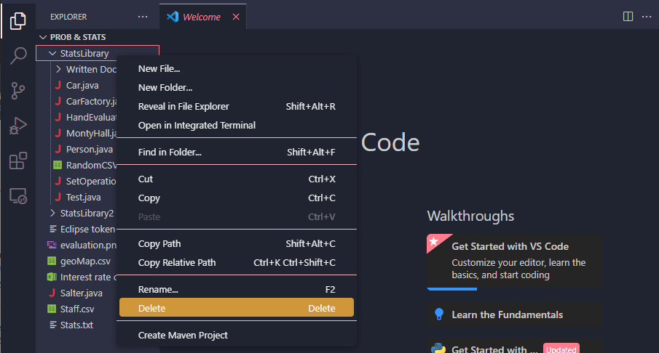

After right clicking maven project and selecting custom command



<https://finance.yahoo.com/quote/DIS/history/>